Energetic Profile-Based Protein Comparison: A New and Fast Approach for Structural and Evolutionary analysis

Peyman Choopanian1, 2, Jaan-Olle Andressoo1, 2, 3*, and Mehdi Mirzaie1, 2*

1Translational Neuroscience, Department of Pharmacology, Faculty of Medicine and Helsinki Institute of Life Science, 00014 University of Helsinki, Finland

2Department of Pharmacology, Faculty of Medicine, 00014 University of Helsinki, Finland

3Division of Neurogeriatrics, Department of Neurobiology, Care Sciences and Society (NVS), 17177 Karolinska Institutet, Sweden

**Abstract**

In structural bioinformatics, the efficiency of predicting protein similarity, function, and evolutionary relationships is crucial. Our innovative approach leverages protein energy profiles derived from a knowledge-based potential, deviating from traditional methods relying on structural alignment or atomic distances. This method assigns unique energy profiles to individual proteins, facilitating rapid comparative analysis for both structural similarities and evolutionary relationships across various hierarchical levels. Our study demonstrates that energy profiles contain substantial information about protein structure at class, fold, superfamily, and family levels. Notably, these profiles accurately distinguish proteins across species, illustrated by the classification of coronavirus spike glycoproteins and bacteriocin proteins. Introducing a novel separation measure based on energy profile similarity, our method shows significant correlation with a network-based approach, emphasizing the potential of energy profiles as efficient predictors for drug combinations with faster computational requirements. Our key insight is that the sequence-based energy profile strongly correlates with structure-derived energy, enabling rapid and efficient protein comparisons based solely on sequences.

**Keywords:** Energy-based annotation, Structural dissimilarity, Evolutionary relationships, Profile of energy, Knowledge-based potential.

**Introduction**

A thorough understanding of protein function holds paramount importance within the domains of biology, medicine, and pharmacy. While experimental methods exhibit high accuracy in protein function associations, their inherent limitations, such as being time-intensive and expensive, have instigated the exploration of computational alternatives. The evaluation of protein similarity by comparing two proteins has consistently emerged as a key methodology. This assessment plays a pivotal role in uncovering insights into the functions and evolutionary relationships of proteins. Advances in high-throughput technologies have led to the establishment of extensive repositories containing protein sequences, a substantial proportion of which, however, lack annotations 1. The significant advancements in omics data and the evolution of machine learning techniques have propelled progress in protein research, transitioning from traditional methods like PSI-BLAST 2 to more sophisticated approaches 3. In the realm of machine learning research, a crucial step is encoding data as input. Although there is no universal approach, encoding amino acid sequences or structural features has been widely adopted for various protein function predictions, including drug-protein interactions 4, anti-hypertensive peptides 5, and RNA-protein interactions6. Despite the diversity in methodologies, the underlying commonality revolves around determining protein similarity either through sequence alignment or structural comparison.

Protein structure is a fundamental feature affecting function, and activity. The energy of a protein structure plays a key role in determining its structure. Knowledge-based potentials, categorized as statistical energy functions, are derived from databases of known protein structures that empirically capture the most probable state of a protein and describe microstates of interactions within protein structure 7, 8, 9. The concept of using energy profiles to evaluate protein structures was initially introduced by Eisenberg10, who developed a method for mapping amino acid sequences to structural folds based on energy profiles. This approach enabled an early computational framework for assessing the compatibility of protein sequences with specific structural conformations. Soon after, Wolynes and co-workers11 expanded this study by applying energy landscape theory, utilizing optimized Hamiltonians to predict protein folding pathways. They introduced the spin-glass model to navigate the complex energy landscape of protein folding, ensuring that the native fold represents a global energy minimum. These pioneering methods laid the groundwork for modern approaches that predict protein structures using energy-based techniques.

It is generally assuming that a native protein structure is confined to a state with the minimum total energy, and the more similar a structure is to the native state, the closer its total energy is to the native state. However, we take a step beyond this assumption and suggest a hypothesis that two similar proteins possess analogous energy profiles. To evaluate this hypothesis, we assigned an energetic feature vector to each protein, with each entry representing the summation of energies for a specific pair of amino acids. With 20 amino acids in proteins, this resulted in 210 pairwise interaction types. This is the first study to assign an energetic feature vector to each protein for comparative analysis. This 210-dimensional vector represents the intricate energy landscape inherent to the structural diversity of proteins. This vector of energies serves as the cornerstone of our analytical approach and provides a robust foundation for further investigative pursuits. Given the current issue of experimentally determining the three-dimensional structures of proteins, estimating energy based on sequence emerges as a crucial consideration. Dostari et al. 12 introduced a method to estimate energy based on amino acid composition. In our study, we drew inspiration from their approach to extract the energy profile based on protein sequence.

The stratification of proteins into distinct folds, superfamilies, and families, guided by evolutionary consanguinity or shared structural and functional attributes, is crucial for precise function prediction. Databases like CATH (Class, Architecture, Topology, Homologous superfamily) 13 and SCOP (Structural Classification Of Proteins) 14 categorize proteins into hierarchical groups based on structural feature, from broad classifications like folds and classes to finer details such as superfamilies and families. To assess profile of energies at various levels, we utilized the ASTRAL40 (95) datasets from SCOPe as a benchmark dataset 15. Comparing energy and distance between profiles estimated from both sequence and structure revealed a high correlation on protein domains from both ASTRAL40 and ASTRAL95 datasets. UMAP projections provided additional evidence that the profile of energy encapsulates structural information at fold, superfamily, and family levels, as observed through random selections. Our method demonstrated superior performance in terms of both accuracy and computational efficiency compared to currently available tools.

In the realm of structural biology and evolutionary analysis, three-dimensional protein structure classification and the alignment of multiple sequences stand as formidable tools for uncovering structural similarities and deducing phylogenetic relationships. We also evaluated our method to reconstruct evolutionary relationships among proteins from the ferritin-like superfamily that are beyond the "twilight zone" 16 —a sequence similarity range (typically 20-35% identity) that complicates the differentiation between true homologs and random matches due to insufficient sequence conservation. Our findings strongly suggest that a substantial and valuable evolutionary signal is preserved within the profile of energy, serving as a representative indicator of protein structure. To assess the discriminatory capacity of energy profiles in discerning proteins across various species, we chose the spike glycoproteins from three coronavirus species 17. Our findings indicate that both sequence-level and structural-level energy profiles successfully cluster proteins from distinct species. In a separate analysis, we computed the sequence-based energy profile for a diverse set of bacterial protein families known as bacteriocins. The identification and understanding of these peptides are crucial due to their ecological significance, but their diverse sequences and structures present challenges for conventional identification methods. The BAGEL data set includes 689 proteins18, each with a length greater than 30 amino acids, providing a comprehensive and challenging benchmark for evaluating peptide identification techniques. Our findings highlight that the energy profile can categorize these proteins based on BAGEL annotation, demonstrating the effectiveness of our method in handling the complexity and diversity inherent in bacteriocin sequences.

The identification of effective drug combinations, essential for treating complex diseases, face challenges due to the combinatorial explosion of potential drug pairs. Cheng et al. introduced a network-based methodology leveraging the human protein-protein interactome to discover clinically effective drug combinations, demonstrating that topological relationships between drug-target modules, as indicated by a separation measure, reflect both biological and pharmacological relationships 19. In our study, we introduce a separation measure based on the similarity between profile of energies of protein targets, revealing a significant correlation with the separation measure derived from the protein-protein interaction network. This suggests that the profile of energy holds promise as a reliable predictor for drug combinations, requiring only protein sequences and offering quicker computation compared to network-based approaches. Therefore, this study offers a means to characterize and compare proteins using profile of energies, enabling predictions of their structural and functional properties.

**Results**

Knowledge-based potentials are derived from databases of known protein structures. Various potential functions, such as distance-dependent, dihedral angles, and accessible surface energies leverage information from known protein structures to estimate energies of pairwise interactions 8. In our investigation, we employed the potential function, where atom contacts were identified using the tessellation method, as outlined in the method section 20. For each protein structure, contacts between atoms were determined through the tessellation method, and the energy for each pair of amino acid types was estimated using equation (2) in the Method section. With 20 amino acids present in proteins, this process resulted in 210 pairwise interaction types. This 210-dimensional vector represents the energy landscape inherent in the structural diversity of proteins. For each pair of proteins, the Manhattan distance between the profiles of energies is considered a measure of dissimilarity between them. Given the current issue of experimentally determining the three-dimensional structures of proteins, estimating energy based on sequence pertains as a crucial subject. We utilized equation (5) to construct the profile of energy based on sequence.

**Correlation between Energy estimated based on structure and Sequence.**

To examine the profile of energy at various levels of SCOP, we employed the ASTRAL40 (95) database (version 2.08) from SCOPe as a benchmark dataset, comprising domains with no more than 40% (95%) sequence similarity, as determined by BLAST identity, and filtered for E-value similarity scores 15. This dataset offers a comprehensive description of structural and evolutionary relationships among proteins from the Protein Data Bank. At first, we calculated energies for protein domains in the ASTRAL40 and ASTRAL95 datasets using both structure- and sequence-based methods. Fig. 2A depicts the relationship between the total energy derived from the structure (on the y-axis) and from the sequence (on the x-axis), with the ASTRAL40 on the left and ASTRAL95 on the right side of the figure. The observed high correlation coefficient suggests that sequence-based energy estimation serves as a reliable approximation and can be effectively used in scenarios where the protein structure is unidentified.

For every pair of domains within the ASTRAL40 (ASTRAL95) datasets, the distances between their profile of energy were computed utilizing both structural and sequence-based energy estimation. In Fig. 2B, the x-axis denotes the distance between Compositional Profile of Energies (CPE), while the y-axis represents the distance between Structural Profile of Energies (SPE)(for more details see the method section). The figure reveals a strong correlation between the distances estimated through structural and sequence-based approaches. Hence, the energy estimation based on sequence data is deemed sufficiently reliable.

We also computed the total energy for protein sequences and their corresponding structures using protein domains from the ASTRAL40 dataset. We then analyzed the differences between these two energy estimates. As illustrated in Fig. 2C, we specifically investigated the correlation between these energy differences and protein length. Our results show no significant correlation, indicating that the accuracy of sequence-based total energy estimates is not affected by protein length. This suggests that sequence-based energy calculations provide a reliable approximation of structural energies, even for proteins of varying lengths. To further support our findings, we extended our analysis to examine energy discrepancies for all interaction types. For each interaction type, we calculated the difference between energy estimates derived from sequence and structure. As shown in Fig. 2D, for 96% of interaction types, the correlation between these energy differences and protein length was less than 0.5. This indicates that protein length has no effect on the accuracy of energy estimates across most interaction types, reinforcing our conclusion that sequence-based energy approximations are robust across different protein interactions. The scatter plots for all 210 interaction types are provided in supplementary figure S1.

However, while protein length does not seem to influence the accuracy, we recognize that protein complexity—such as folding patterns, structural heterogeneity, and conformational dynamics—could still play a role in the precision of energy estimates. These factors might affect the energy landscape in ways that are not fully captured by sequence-based methods. Therefore, exploring the impact of protein complexity on energy estimations will be a valuable direction for future research.

The stability, mutational robustness, and design adaptability of α-helices relative to β-strands in natural proteins have been widely acknowledged in scientific literature. To investigate this phenomenon, Fig. 3 presents the distribution of total energy within protein domains from the ASTRAL40 and ASTRAL95 datasets, categorized into four structural scope classes: all-alpha, all-beta, alpha + beta, and alpha/beta. Total energies, normalized by protein length, are analyzed to discern patterns across these structural classes. The figure highlights significant differences in total energy among domains with different structural compositions, suggesting diverse energetic landscapes associated with distinct protein structures. This observation is consistent with similar trends observed in energy estimations derived from sequence information (Fig. 3B).

**3.2 Unveiling the Energy Patterns Across SCOP Hierarchy**

We visualized energy profiles derived from sequence and structure for domains within the all-alpha and all-beta classes. As shown in Fig. 4, UMAP embeddings effectively capture structural characteristics distinguishing all-alpha and all-beta domains. This visualization reveals distinct energy patterns between these classes, a consistency also found in sequence-based analyses. To explore structural information at lower hierarchical levels of SCOP, two folds (a.100 and a.104) from the all-alpha class, two superfamilies (a.29.2 and a.29.3) from fold a.29, and two families (a.25.1.0 and a.25.1.2) from superfamily a.25.1 were randomly selected. Fig. 5 displays two figures per panel, with the left figure illustrating CPE profiles and the right figure showcasing SPE profiles. UMAP plots in Fig. 5 demonstrate that protein domains within the same fold, superfamily, or family share similar energy patterns and cluster together.

To delve deeper into differences in distances among protein domains within the same class, we calculated pairwise distances for domains within the all-alpha class from the ASTRAL95 dataset. Subsequently, these distances were compared with distances from domains across different classes. As shown in Fig. 6A-B, intraclass distances in purple are significantly lower than interclass distances in yellow. Similar results were obtained when calculating pairwise distances from domains within fold a.29 and comparing them with distances from domains in different folds within the all-alpha class. Likewise, distances between energy patterns of domains within the same superfamily a.29.3 are significantly less than distances between energy patterns of domains within fold a.29 that belong to different superfamilies (Fig. 6C-D). Consequently, it can be inferred that energy patterns of domains belonging to the same superfamily/fold/class exhibit higher similarity than those from different superfamilies/folds/classes.

It is commonly assumed that proteins sharing similar structures also exhibit similar functions. Several measurements have been developed to assess protein structure similarity, each offering unique insights. Root Mean Square Deviation (RMSD)21 quantifies the average spatial variance between corresponding atoms or components within superimposed proteins, providing a fundamental measure of structural deviation. For our analysis, RMSD calculations were performed by superimposing corresponding atomic coordinates using a least-squares fitting procedure implemented in R, focusing on backbone Cα atoms to assess the overall fold without the influence of side-chain orientations. While RMSD is widely used, it heavily relies on direct spatial overlap and is sensitive to outlier regions. This sensitivity often penalizes flexible regions or domain movements, such as hinge motions or flexible loops, potentially obscuring meaningful similarities in overall protein fold when local variations are present. The TM-score (Template Modeling score) 22 evaluates similarity by considering both residue-level alignment and overall topology, offering a nuanced assessment of structural resemblance. Unlike RMSD, TM-Score is less sensitive to domain-level movements but has its own limitations. Specifically, when comparing proteins with highly variable structures or multi-domain proteins, TM-Score tends to favor the alignment of larger structural elements, potentially leading to lower scores for proteins with significant domain rearrangements despite sharing similar overall folds. Additionally, TM-Score may not adequately account for functional sites that involve small but critical local structural differences. TM-Vec 23, a recent advancement, employs deep learning techniques trained on diverse protein structures to enhance accuracy and efficiency in similarity assessment. TM-Vec maps protein structures into a continuous vector space, allowing comparisons based on the distances between their vector representations. While highly accurate in detecting remote homology and structural similarities, TM-Vec’s reliance on training data introduces inherent biases. These biases are particularly evident when evaluating proteins with rare or novel folds that are underrepresented in the training set. Furthermore, as a black-box model, TM-Vec offers limited interpretability regarding the specific structural features contributing to the similarity scores, which can be a limitation when detailed structural insights are required. On the alignment front, we utilized GR-Align24 with its default parameters, employing the graphlet degree similarity (GDS) metric to capture topological similarities between protein structures. The GDS metric compares the distributions of small connected subgraphs (graphlets) within the protein structures. GR-Align is robust in identifying proteins with similar topological arrangements, but its sensitivity to minor structural variations can lead to higher false positives when comparing proteins with subtle differences in their tertiary structures. Additionally, GR-Align does not incorporate sequence information or account for conformational flexibility, which may limit its ability to discern functionally relevant structural variations, particularly those involving dynamic regions of proteins. Finally, the Hausdorff distance25 provides a measure of dissimilarity between sets of points, offering further insight into structural comparisons. In our study, the Yau-Hausdorff distance was calculated by comparing point sets representing the protein structures, specifically using distances from the structural centroids to the Cα atoms. This method captures overall geometric differences between structures by measuring the maximal deviation between point sets in a bidirectional manner. However, it may not fully account for local structural variations or conformational changes, such as those occurring at active sites or ligand-binding regions, which are crucial for functional similarity. Moreover, the method assumes that global geometric similarity correlates with functional similarity, which may not always hold true, especially for proteins whose function is dictated by specific local conformations. Here, we employed a benchmark dataset sourced from the CATH v4.2.0 database, comprising 251 protein domains from two distinct protein families: the C-terminal domain in the DNA helicase RuvA subunit (representing the Alpha class, characterized by Orthogonal Bundle Architecture, Helicase, and Ruva Protein fold, with CATH Code: 1.10.8.10), and the Homing endonucleases (belonging to the Alpha and Beta class, featuring Roll Architecture, and Endonuclease I-creI fold, with CATH Code: 3.10.28.10). The protein domains varied in the number of residues, ranging from 44 to 854, with an average of 211.

We used the 1-NN classification method to categorize proteins based on GR-Align, RMSD, TM-score, Yau-Hausdorff distance, TM-Vec, and the distance between energy profiles as a measure of protein dissimilarity. As shown in Table 1 and Fig. 7, CPE method achieves a computation time faster than TM-Vec. Moreover, CPE and SPE methods significantly outperforms GR-Align, RMSD, TM-Score, and YH in terms of accuracy and efficiency, highlighting a substantial advantage. Our method eliminates the need for superimposing protein structures or conducting structural alignments; instead, we calculate energy profiles and measure the distance between them. Table 1 details result and processing times, demonstrating the efficient implementation of CPE calculation and the 1-NN algorithm, completed in one second on a system with a 2.4 GHz processor and 4GB RAM. CPE and TM-Vec achieved a remarkable classification accuracy of 100% in distinguishing between two protein families.

To assess the profile of energy in protein superfamily classification, we investigated five distinct SCOP superfamilies: winged helix (a.4.5), PH domain-like (b.55.1), NTF-like (d.17.4), Ubiquitin-like (d.15.1), and Immunoglobulins (b.1.1) 26. Our classification strategy incorporated energetic profiles CPE as features, employing 1-nearest neighbor (1-NN) and Random Forest (RF) classifiers as our models. To ensure the robustness and generalization of our models, we subjected RF to rigorous 10-fold cross-validation. The results, summarized in Table 2, include metrics for accuracy and F1-score, demonstrating the effectiveness of our model. Both classifiers show performance levels close to 100%, as illustrated in Table 2. We compared the CPE and SPE method with TM-Vec. As depicted in Table 2, our results in CPE method are not only comparable to TM-Vec in terms of accuracy but also demonstrate a faster performance.

To further validate our approach, we also analyzed the two subfamilies, α and β globins, which are part of the hemoglobin biological unit. Although α and β globins are closely related and share a common evolutionary origin, they have distinct and well-characterized functions within the hemoglobin α2β2 tetramer, despite their highly similar structures. Freiberger et al.27 utilized a non-redundant set of experimental structures representing 21 mammalian hemoglobins (both α- and β-globins), and their analysis revealed distinct patterns of conserved energetic frustration, corresponding to their divergent functional roles in hemoglobin. Notably, specific residues exhibited highly frustrated interactions in one family while maintaining stability in the other, indicating evolutionary adaptations that reflect the unique structural and functional demands of each globin subunit. We computed the CPE, SPE, and TM-Vec representations for this dataset. Fig. 8 presents the UMAP projection for these proteins, where all methods effectively differentiate between the α and β globins.

**3.4 Phylogeny Inference of the Ferritin-Like Superfamily**

In conjunction with the organizational frameworks provided by SCOP, CATH, and Pfam for the protein universe, it is important to note their limitations, as they may present conflicting classifications and lack the ability to elucidate evolutionary relationships between individual superfamilies across long evolutionary distances. Lundin et al. conducted a comprehensive analysis of protein structures within the functionally diverse ferritin-like superfamily. They employed an evolutionary network construction approach to unveil relationships among proteins beyond the "twilight zone", where sequence similarity alone fails to facilitate meaningful evolutionary analysis. Building on this context, our study leverages profiles of energies to reconstruct a phylogenetic network. Our findings strongly suggest that a substantial and valuable evolutionary signal is preserved within the profile of energy, serving as a representative indicator of protein structure. Lundin et al. 16 investigated how ferritin-like proteins are classified across Pfam, SCOP, and CATH. Notably, this superfamily encompasses a diverse range of proteins, including iron-storing ferritins, methane monooxygenases, the small subunit of Ribonucleotide reductase-like (RNR R2), rubrerythrins, bacterioferritins, Dps (DNA binding protein from starved cells that protects against oxidative DNA damage), and Dps-like proteins. As discussed by Lundin et al.16 at the superfamily level, the classification of the “ferritin-like” superfamily appears consistent across these databases but does differ in the amount of information provided regarding the relationships and functions of superfamily constituents. So, although the classification in all three databases is hierarchical, they do not encompass all level of functional and evolutionary information. The low sequence similarities across this superfamily make it feasible to construct sequence-based phylogenies only for specific subsets. Consequently, addressing this challenge requires efforts to integrate structural information with sequence-based phylogenies. Malik et al. 28, and Puente-Lelievre et al. 29 delved into the evolutionary relationships of this superfamily by creating a phylogenetic network.

They employed the distance-based NeighborNet network method 30, utilizing distances calculated through structure-based alignment methods. Fig. 9A depicts the schematic tree built by Malik et al.28, and Lelievre et al. 29. We employed the same protein structures within this superfamily as utilized by Malik et al.28 and Lelievre et al. 29 to reconstruct the phylogeny of based on profile of energies. The dataset specifically focuses on the SCOP superfamily, Ferritin-like (a.25.1) encompassing two manually curated protein families: Ferritin (a.25.1.1) and RiboNucleotide Reductase-like [RNR] (a.25.1.2). The “Ferritin” family contains ferritins, bacterioferritins, and Dodecameric ferritin homolog (Dps) proteins and the “RiboNucleotide Reductase-like” family contains the activating subunit of class I ribonucleotide reductase (RNR R2), BMM, and Fatty acids 16. Following this, we computed SPE for each protein and calculated all pairwise distances between SPEs. The phylogenetic tree, constructed using the phangorn package 31, was visualized through the SplitTree software 32 and is presented in Fig. 9B.

Our results suggest that the energetic phylogenies within the ferritin-like superfamily unveil significant relationships among its members, aligning with known evolutionary relationships and functional roles. In line with prior investigations, a key observation is that the resulting phylogenetic tree exhibits two primary branches, corresponding to two families a.25.1.1 and a.25.1.2. Thus, our methodology accurately bifurcates this superfamily into two families. Delving into specifics, the family a.25.1.1 (depicted by orange color triangles) further divides into four subgroups: "ferritins", "Dps", "Rubrerythrin", and "Bacterioferritins" indicated by distinct colors in Fig. 9B. On the other hand, the second branch related to the a.25.1.2 family (dark blue triangles), despite SCOP and CATH assigning these proteins to a unified RNR-like family, reveals three distinct families according to Pfam—Phenol_Hydrox (PF02332), Ribonuc_red_sm (PF00268), and Fatty acid desaturase (PF03405). Our results consistently support this more detailed sequence-based classification, as well as the further subdivision of the BMMs into BMMa and BMMb. The protein groupings presented by Lelievre et al. in Fig. 9A are color-coded, corresponding to the colors used in Fig. 9B, C. Our approach successfully reconstructed the phylogenetic tree using the energy profile. However, as shown in Fig. 9C, the phylogenetic tree generated by the TM-Vec representation and cosine similarity could delineate two distinct branches corresponding to two protein families but failed to predict the evolutionary relationships within each protein family as proposed by Lelievre et al. The dashed line in Fig. 9B-C demonstrates that both the energy model and the vector model effectively distinguish between the Ferritin and Ribonucleotide reductase-like families.

In Fig. 9B, the energy profile model accurately orders the divergence of proteins within the Ferritin family, following Lelievre et al.'s order of rubrerythrins, Ferritins, and then Dps and bacterioferritins. Conversely, for the Ribonucleotide reductase-like family, the energy profile model reconstructs the proposed evolutionary order of Fatty acids, RNR R2, and then BMM. In contrast, the phylogenetic tree reconstructed using the TM-Vec model, while capable of differentiating the two families, does not align with the evolutionary order suggested by Lelievre et al. For example, within the Ferritin family, Lelievre et al.'s model posits that Dps diverged later, whereas the TM-Vec model indicates it as the first group to separate. Similarly, for the Ribonucleotide reductase-like family, the TM-Vec model places the BMM proteins as the earliest branch in the phylogenetic tree, whereas Lelievre et al.'s model suggests they were among the last to diverge.

**3.5 Clustering of the SARS-CoV-2, SARS-CoV and 2012 MERS-CoV proteins**

Over the past two decades, coronaviruses (CoVs) have been linked to several significant outbreaks, including the SARS-CoV outbreak in 2002-2003, the MERS-CoV incident in 2012, and the recent COVID-19 pandemic caused by SARS-CoV-2 in late 2019. Since February 2020, a substantial number of SARS-CoV-2 protein structures have been deposited in the Protein Data Bank (PDB), with the spike glycoprotein being of particular interest due to its crucial role in viral infection by mediating host receptor binding. This protein is a primary target for neutralizing antibodies and vaccine development.

To explore the structural landscape and evolutionary relationships of these spike glycoproteins, we used the CoV3D database(https://cov3d.ibbr.umd.edu), which provides a comprehensive collection of coronavirus protein structures and their interactions with antibodies, receptors, and small molecules17. From this resource, we curated a dataset of 143 spike glycoprotein structures, all containing a closed receptor-binding domain (RBD). This dataset comprises 80 spike protein chains from SARS-CoV-2, 31 from SARS-CoV, and 32 from MERS-CoV.

We performed a multiple sequence alignment of the spike proteins using the msa package in R with the ClustalW method. Protein distances were calculated using the seqinr package, based on the number of identities as the distance metric. Phylogenetic trees were then constructed using the UPGMA method in the phangorn package, and the resulting tree, based on sequence similarity, is shown in Fig. 10B.

To analyze structural variations and relationships among the spike glycoproteins, we generated 210-dimensional energy profiles at both the sequence and structure levels. By calculating Manhattan distances between all pairs of energy profiles, we clustered the spike glycoproteins into three distinct groups corresponding to SARS-CoV, MERS-CoV, and SARS-CoV-2. This clustering provides a clear visual representation of the structural and evolutionary relationships within this protein family, as shown in Fig. 10A, D. The lineage of SARS-CoV and SARS-CoV-2 is clearly distinct from MERS-CoV, which belongs to a different subgenus of coronaviruses. However, as shown in Fig. 10C, E, and F, methods such as RMSD, TM-Score, and TM-Vec are less effective in reconstructing these evolutionary patterns. For example, certain SARS-CoV-2 proteins are misclassified, appearing far from their respective groups (highlighted by orange circles in Fig. 10C). Similarly, the TM-Vec method misclassifies some SARS-CoV proteins and fails to correctly group MERS-CoV proteins. We also conducted a bootstrap analysis with B = 100 replicates to assess the robustness of phylogenetic tree reconstructions using CPE, SPE, TM-Vec, and MSA methods. Confidence intervals were also calculated to statistically validate the accuracy of the results. The bootstrap results and confidence intervals for the main branches that distinguish the three species are now presented in the relevant figures within the manuscript, further supporting the reliability of the energy profile-based model in reconstructing the phylogenetic tree. Detailed bootstrapping results for all branches are available in Supplementary Figures S2-S5.

In terms of computational efficiency, our methods—CPE and SPE—are significantly faster than the alternatives. CPE completes the analysis in 0.9 seconds, and SPE takes just 3 minutes, whereas TM-Vec requires 89 seconds, RMSD takes 70 minutes, and TM-Score takes 9.7 hours (Fig. 10H). This demonstrates the computational advantage of our methods, making them both accurate and efficient for clustering analyses. To evaluate clustering performance, we used the Adjusted Rand Index (ARI), which measures the similarity between two clustering results, with values ranging from -1 to 1 (where 1 indicates perfect agreement). As shown in Fig. 10G and Table S1, our sequence-based methods achieved the highest clustering performance with an ARI of 0.95 at a cut tree of 4. TM-Vec performed best at a cut tree of 5, with an ARI of 0.87. Among the structure-based methods, SPE achieved a perfect ARI of 1 at a cut tree of 3, while RMSD and TM-Score performed best at cut trees of 6 and 4, with ARIs of 0.73 and 0.56, respectively (Table 4). These results highlight the robustness of our methods for both sequence- and structure-based clustering. We also computed the average distance between the three virus groups—SARS-CoV, SARS-CoV-2, and MERS-CoV—across all five methods (SPE, CPE, sequence similarity-based, TM-Vec, and RMSD). All methods consistently show that SARS-CoV-2 is more closely related to SARS-CoV than to MERS-CoV (Fig. 10I). Additionally, the distance between SARS-CoV-2 and MERS-CoV is nearly identical to the distance between SARS-CoV and MERS-CoV, confirming that both groups are similarly distant from MERS-CoV.

**3.6. Clustering of Bacteriocins**

Bacteriocins are peptides produced by bacteria that act as strong antibacterial agents against other, typically closely related microbial species. We analyzed the bacteriocins family available in the BAGEL database, those with a length larger than 30 amino acids, including a total of 689 proteins 18. Detecting and understanding these peptides is crucial due to their ecological importance, but their diverse sequences and structures make them challenging to identify using traditional methods. To address this issue, the BAGEL tool was developed in 2006, specifically designed for identifying Ribosomally synthesized and post-translationally modified peptides (RiPP) and bacteriocin biosynthetic gene clusters (BGCs). BAGEL categorizes bacteriocins based on size and stability into RiPPs (also defined as class I bacteriocins by BAGEL), class II bacteriocins (small heat stable proteins < 10 kDa) and class III bacteriocins (large heat-labile proteins > 10 kDa). As shown in Fig. 11A, our analysis revealed that profile of energy (CPE) can clearly partition bacteriocins according to BAGEL annotation. Hamamsy et al. 33 leveraged the deep protein language models to develop the TM-Vec model, which is trained on pairs of protein sequences and their TM-scores. We compared CPE distances to the TM-scores of protein structures predicted by AlphaFold2 34, OmegaFold 35, and ESMFold 36, as well as the TM-Vec predicted by the model. As demonstrated in Fig. 11B, the TM-score of proteins predicted by AlphaFold2, OmegaFold, and ESMFold from the same class is similar to proteins from different classes. TM-Vec is effective at distinguishing between bacteriocins from the same class and proteins from different classes. Although there is some overlap between TM-Vec values from proteins from the same class and other classes. Our method also effectively distinguishes between proteins from the same class and those from other classes in bacteriocin dataset.

**3.7. Effective Drug Combination suggestion using Energetic Signatures**

The identification and validation of effective drug combinations are crucial in the treatment of various complex diseases, aiming to enhance therapeutic efficacy while minimizing toxicity. However, this task is hindered by a combinatorial explosion resulting from the multitude of potential drug pairs. Cheng et al. introduced a network-based methodology to pinpoint clinically effective drug combinations tailored to specific diseases 19. This approach involved assessing the network-based relationships among drug targets and disease proteins within the human protein-protein interactome. By quantifying these relationships, they identified clusters of drugs that exhibited correlations with therapeutic effects. The drugs within these clusters targeted the same disease module but belonged to separate neighborhoods. This innovative network methodology presented by Cheng et al. provides a generic and powerful means to discover effective combination therapies during drug development. Disease proteins were observed to form localized neighborhoods, referred to as disease modules, rather than being randomly distributed throughout the interactome. To characterize the mutual relationship between two drugs and a disease module, they employed the following network-based proximity measure:

$$s_{AB}= <d_{AB}> - \frac{<d_{AA}> + <d_{BB}>}{2} (5)$$

This measure assessed the network proximity of drug-target modules A and B by comparing the mean shortest distance within the interactome between the targets of each drug ( $<d_{AA}>$ and $<d_{BB}>$) to the mean shortest distance between A-B target pairs $<d_{AB}>$. When $s_{AB}<0$, the targets of the two drugs are in the same network neighborhood; when $s_{AB}>0$, the two targets are topologically separated.

The authors demonstrated that the topological relationship between two drug-target modules, as indicated by $s_{AB}$, reflects both biological and pharmacological relationships. They also showed that the network proximity ($s_{AB}$) of drug-drug pairs in the human interactome correlates with chemical, biological, functional, and clinical similarities. This led them to conclude that each drug-target module possesses a well-defined network-based footprint. If the footprints of two drug-target modules are topologically separated, the drugs are considered pharmacologically distinct. Conversely, if the footprints overlap, the magnitude of the overlap indicates the strength of their pharmacological relationship. A closer network proximity of targets in a drug pair suggests higher similarities in their chemical, biological, functional, and clinical profiles.

Here, we used the following separation measure, denoted by $E_{AB},$ based on similarity between profiles of energies of protein targets:

$$E_{AB}= <d_{AB}> - \frac{<d_{AA}> + <d_{BB}>}{2} (6)$$

where

$$<d_{AB}> =\frac{1}{\left\|A\right\|+ \left\|B\right\|}\left(\sum_{a∈A}{\min_{b∈B}{d(a,b)}}+ \sum_{b∈B}{\min_{a∈A}{d(a,b)}}\right)$$

and $d(a,b)$ represents the Manhattan distance between the energy profiles of proteins a and b.

Fig. 12 depicts the correlation between sAB values, as computed by Cheng et al. 19, for a set of 65 antihypertensive drugs exhibiting complementary exposure to the hypertension disease module, and the corresponding EAB. The results demonstrate a strong correlation between $s_{AB}$ and $E_{AB}$, suggesting that the energy profile holds promise for predicting drug combinations. It is important that our approach only requires protein sequences and is significantly faster than computing the shortest path in a protein-protein interaction network.

**3.8 Large-Scale Application of Family Detection in Coronaviruses**

To evaluate our method on a larger dataset, we utilized a coronavirus dataset that was previously generated and analyzed by Freiberger et al.27 Initially, they retrieved homologous sequences from the SARS-CoV-2 reference genome MN985325, with low-quality and non-Coronaviridae sequences excluded37. Then sequences aligned using MAFFT software38, with non-structural protein sequences trimmed to focus on regions specifically relevant to SARS-CoV-2. These aligned sequences were then clustered using CD-Hit39 to ensure high similarity within each cluster. Structural models for these sequences were generated using AlphaFold2, retaining only those that met stringent quality criteria. The high-quality models were subsequently grouped into subfamilies using S3Det software40, allowing for the identification of Specificity Determining Positions (SDPs) within the proteins. This meticulous process resulted in a final set of 28 high-quality protein families, comprising 4,405 protein models. For each protein in this dataset, we computed the energy profiles CPE and SPE, along with the distance between these profiles and the cosine similarity between pairs of TM-Vec representations. The 1-nearest neighbor (1-NN) method was then utilized to classify the proteins into different families. The results, shown in Table 5, include metrics for accuracy and F1-score, demonstrating the effectiveness of our model. Both methods achieved performance levels near 100%, with CPE offering faster performance. Detailed outcomes of the 1-NN classification are provided in Supplementary Tables S3-S5, and the UMAP projections of SPE, CPE, and TM-Vec representations are displayed in Supplementary Figures S6-S8.

The Papain-like Protease (PLPro) domain plays a crucial role in viral replication by catalyzing the proteolysis of viral polyproteins. In addition, PLPro interacts with two host proteins, ubiquitin (Ub) and the ubiquitin-like interferon-stimulated gene 15 protein (ISG15), allowing the virus to evade or weaken the host immune response. In this dataset, PLPro is divided into four subfamilies aligned with the Betacoronavirus subgenera: Sarbecovirus (n = 31), Nobecovirus (n = 11), Merbecovirus (n = 35), and Embecovirus (n = 45). The UMAP representation for both CPE and SPE is shown in Fig. 13, where proteins from each subfamily are clearly clustered together.

**Discussion**

The continuous growth of protein databases highlights the importance of understanding their functional characteristics. It's widely recognized that proteins with similar structures often perform similar functions. Additionally, there's a common belief that proteins with similar structures also share similar energy levels. Therefore, our study aims to pioneer a new approach by directly linking protein energy landscapes to their functional attributes. By investigating this relationship, we seek to uncover new insights into how protein structure, energetics, and biological activity are interconnected. Knowledge-based potentials are energy functions derived from known protein structures. In our study, we used the DBNI potential function20 to calculate the energy between pairs of amino acids, generating energy profiles based on both sequence and three-dimensional structure. A significant achievement of our study is the high correlation observed between energy estimates derived from sequence and those from structural data, allowing for the derivation of energy profiles based solely on sequence information, which enables fast and accurate computational analysis. However, it's worth noting that the reliance on knowledge-based potentials is dependent on known protein structures, potentially limiting the generalizability of results to proteins with varied structural characteristics or those are underrepresented in existing databases. Furthermore, despite the promising correlation between energy estimates derived from sequence and structural data, it is possible that there are complexities in accurately capturing the entirety of protein energetics solely from sequence information, which could affect the reliability of the resulting energy profiles. To address these issues, one possible option is to adjust the energy profile, such as through reweighting, to specific applications, such as protein remote homology detection or drug-target affinity prediction.

We employed Uniform Manifold Approximation and Projection (UMAP) to visualize energy profiles at both sequence and structural levels derived from protein domains within the ASTRAL database, revealing their capacity to distinguish proteins across various hierarchical levels, including class, fold, superfamily, and family. Notably, the Manhattan distance between energy profiles serves as a measure of dissimilarity, eliminating the necessity for structural or sequence alignment in protein comparison and resulting in significantly faster computational analyses, as demonstrated in Table 2. The comparison table highlights notable differences in both accuracy and computational efficiency among the methods evaluated. The profile of energy (CPE) method demonstrates a remarkable accuracy of 97%, significantly surpassing other methods such as GR-Align, RMSD, and TM-Score, which range from 59.2% to 81.5%. This indicates that the CPE method excels in accurately distinguishing between protein structures at different superfamilies, showcasing its superiority in capturing structural dissimilarities effectively. In terms of computational efficiency, the CPE method stands out as the most time-efficient, requiring a mere 3 minutes for processing. In contrast, traditional methods like RMSD and TM-Score demand significantly longer computational times, ranging from 1 hour to over 9 hours. For instance, the CPE method is approximately 20 times faster than RMSD and 180 times faster than TM-Score. This stark difference underscores the efficiency of the CPE method, particularly in time-sensitive scenarios or large-scale protein structure comparison tasks.

Our method's efficacy was further assessed by comparing its results with structural dissimilarity metrics such as RMSD, TM-Score, and GR-align in classifying proteins across five distinct SCOP superfamilies, showcasing its superior accuracy and computational efficiency. Particularly challenging is elucidating evolutionary relationships among superfamilies beyond the "twilight zone," where sequence similarity alone proves inadequate for meaningful analysis. To address this, we examined energy profiles to reconstruct a phylogenetic network of the Ferritin-like superfamily, incorporating proteins from the twilight zone. Our analysis, consistent with previous studies by Lundin et al16 and Malik et al.28, unveiled substantial and valuable evolutionary signal preserved within energy profiles, indicating their potential as representative indicators of protein structure. Moreover, we examined the structural attributes of spike glycoproteins among three coronaviruses—SARS-CoV, MERS-CoV, and SARS-CoV-2—using a 210-dimensional energy profile combined with Manhattan distances. This study successfully grouped these proteins into specific clusters corresponding to each virus, offering insights into their structural and evolutionary relationships. Additionally, our inquiry extended to 689 proteins within the bacteriocins family, encompassing various sizes and stability levels sourced from the BAGEL database. By employing the energy profile (CPE), we effectively distinguished bacteriocins according to BAGEL classifications, showcasing the usefulness of this method in protein classification, particularly in scenarios where proteins exhibit differing stabilities. Comparative analysis involving TM-scores from a range of prediction models emphasized the effectiveness of our approach in differentiating proteins within and across classes, thereby providing valuable insights into bacteriocins. In summary, our findings underscore the valuable insights offered by energy profiles across structural, functional, and evolutionary scales.

One of the significant applications of assessing protein similarity lies in quantifying the proximity between two drugs based on their protein targets. When the protein targets of two drugs exhibit similarity, it is reasonable to anticipate similarities in the drugs themselves. Our method, capable of quantifying the dissimilarity between two proteins, potentially encodes functional information that can be leveraged to gauge the similarity between two drugs according to their protein targets. Comparative analysis with a study conducted by Cheng et al.19 demonstrates a notable correlation between our results, derived solely from protein sequence data, and theirs, obtained using protein-protein interaction data. It is worth reiterating that our method boasts remarkable speed compared to conventional approaches. By providing a rapid yet effective means of assessing protein similarity, our method offers promising implications for drug discovery and development, facilitating the identification of potential drug candidates with similar protein targets. This underscores the significance of leveraging computational methods to expedite drug discovery processes while maintaining robustness and accuracy. In conclusion, our research introduces the energy profile as an innovative feature set containing significant functional insights that can be utilized to represent proteins within machine learning methodologies for predicting protein function, drug-target interactions, and drug combination outcomes.

In our investigation, we examined the energy profile surrounding protein drug targets and demonstrated a strong correlation between our scoring system and that derived from protein-protein interaction networks. It's important to acknowledge that while a more sophisticated computational approach and experimental validation are crucial in drug combination study, these aspects fall beyond the purview of our manuscript.

Moreover, while our method bears significant implications for drug discovery and development, its efficacy might be limited by the availability and quality of protein sequence and structural data, as well as the inherent complexity of drug-target interactions. Therefore, it is imperative for independent research endeavors to address this crucial aspect and offer comprehensive insights into the practical application of our approach in real-world therapeutic contexts.

To evaluate the scalability of the CPE method, we performed an additional analysis by randomly selecting protein subsets from the Astral95 dataset, ranging in size from 1,000 to 30,000 proteins (at intervals of 5,000). For each subset, we computed the pairwise distances between proteins using both the CPE and TM-Vec methods, while also recording the processing time per amino acid. This metric represents the total computation time divided by the cumulative number of amino acids across all analyzed protein domains. As shown in Fig. 14, both methods demonstrate a linear increase in computation time per amino acid as the dataset size expands. However, the CPE method exhibits a gentler slope compared to TM-Vec, indicating superior scalability. These findings underscore the efficiency of the CPE method, particularly for handling large, complex datasets, making it highly suitable for high-throughput computational studies.

The CPE method leverages energy profiles derived from pairwise amino acid interactions, where each dimension of the energy vector corresponds to specific amino acid pairs. This structured, physically grounded representation makes the data more intuitive and interpretable because the calculated energy values directly reflect biologically meaningful aspects of protein interactions, such as stability, folding, and molecular dynamics. This clarity allows researchers to trace protein similarities back to the underlying energy landscapes, which are well-established in protein science.

In contrast, TM-Vec utilizes deep learning embeddings that, although highly effective, function as a "black box." While TM-Vec can identify remote homologies and structural similarities, the embeddings it generates are abstract and difficult to deconstruct in a biologically meaningful way. This limits the ability to draw direct connections between the model's outputs and the physical or functional properties of proteins.

The CPE method, by focusing on energy profiles, offers distinct advantages in terms of interpretability. Energy profiles are inherently linked to protein folding, stability, and interaction networks, which are fundamental to biological function. For example, an increase in energy in specific pairwise interactions might suggest destabilizing mutations or conformational shifts that affect protein function. This explicit connection between energy and structural features allows for more transparent insights into how variations in energy impact the overall behavior and evolutionary relationships of proteins. By directly correlating these energy states with functional classifications such as folds, superfamilies, or evolutionary relationships, CPE provides clearer, actionable insights for researchers.

Additionally, because energy profiles can be tied to specific biophysical principles—such as electrostatic interactions, hydrophobic effects, or van der Waals forces—CPE offers a mechanistic understanding of protein relationships that is often lacking in machine learning models like TM-Vec. In fields such as drug discovery or protein engineering, where understanding the precise molecular interactions is crucial, CPE provides a significant advantage in generating interpretable and actionable data.

In conclusion, CPE’s reliance on energy profiles provides not only a more interpretable but also a biophysically grounded model of protein similarity. This contrasts with TM-Vec’s deep learning approach, which, while powerful, offers less transparency and explainability. CPE’s approach is particularly valuable in contexts where understanding the biological and structural principles behind protein behavior is critical, such as in evolutionary studies, disease-related mutation analysis, and drug development.

**Methods**

#### Dataset Preparation

A curated dataset of non-redundant protein chains was generated using PISCES41 from the Protein Data Bank (PDB). The dataset was selected based on the following criteria:

* **Pairwise sequence identity:** Less than 50% to ensure non-redundancy.
* **Resolution:** Higher than 1.6 Å to guarantee structural accuracy.
* **R-factor:** Below 0.25 to ensure reliable crystallographic data.
* **Protein length:** Between 40 and 1,000 residues to include proteins of varying sizes while excluding excessively short or long chains.
* **Overlap:** Proteins overlapping with the test sets from this manuscript were removed from the training set.

These filtered proteins were utilized to train and calculate the knowledge-based potential function as follows.

**Pairwise Distance-Dependent Knowledge-Based Potential**

Knowledge-based potentials are derived from databases of known protein structures and are essential for estimating the energies of pairwise interactions. These potentials can be based on various factors, including distance dependencies, dihedral angles, and accessible surface areas. In this study, we employed a distance-dependent potential function where atomic contacts were identified using the tessellation method as follows:

**Contact Identification:**

1. **Representation:** All amino acids in each protein chain were represented by their heavy atoms (excluding hydrogen atoms).
2. **Delaunay Tessellation:** A Delaunay tessellation of the resulting point set was computed using Qhull42, identifying neighboring atoms based on spatial proximity.
3. **Defining Contacts:** Two atoms were considered to be in contact if they are connected by an edge in the Delaunay triangulation. This implies that they are not shielded from each other by other atoms, ensuring direct interaction without obstruction.
4. **Distance Shells:** The distances between contacting atoms were divided into 30 discrete shells, starting at 0.75 Å with each shell having a width of 0.5 Å. This binning allows for the extraction of distance-dependent interaction potentials.
5. **Interaction Range:** Only atoms separated by less than 6 Å were considered to interact. If a third atom exists between two close atoms, preventing direct contact, the interaction was excluded. Additionally, all pairwise interactions within the same residue were omitted to focus on inter-residue interactions.

**Atom Types:** A total of 167 atom types were considered by treating non-hydrogen atoms as distinct based on their specific amino acid residues.

**Energy Calculation:** The potential energy between two atoms $i$   and $j$  at distance $d$ was calculated using the following equation:

$∆E^{ij}\left(d\right)=RT\left[ln\left(1+M_{ij}σ\right) -ln⁡(1+M_{ij}σ(\frac{f_{ij}(d)}{f_{xx}(d)}))\right]$ (1)

where *RT* is constant and equal to 0.582 kcal/mole. $M_{ij}$  is the number of observations for atomic pair $i$  and $j$ , $f_{ij}(d)$ is the relative frequency of occurrence for $i$  and $j$  in distance class $d$, $f_{xx}(d)$ is the relative frequency of occurrence for all atomic pairs in distance shell $d$ , and $σ$ is the weight given to each observation. As discussed by Sippl 7, it was assumed that $σ=0.02$.

The potential energy associated with the interaction of residues A and B denoted by $∆E(A,B)$ is estimated by summing the pairwise potentials between the atoms of each of these residues as follows:

$∆E(A,B)=\sum_{i∈A,j∈B}{∆E^{ij}\left(d\right)}$ (2)

where the sum is over all atom pairs in contact, identified via the Delaunay triangulation method.

**Structural Profile of Energy (SPE):** Given the 20 standard amino acids, there are 210 unique amino acid-amino acid interaction types. For each protein structure, a 210-dimensional vector was created to represent the distance-dependent energy interactions between residues. Each dimension corresponds to the energy interaction between a specific pair of amino acid types. This vector is referred to as the **Structural Profile of Energy (SPE)**.

**Pairwise Energy Content from Amino Acid Composition**

While the knowledge-based potential function relies on having the three-dimensional structure of a protein, many protein structures remain undetermined experimentally. To address this, we developed a method to estimate pairwise energy content based solely on amino acid composition.

**Energy Estimation:** For each protein $S$ in the training set:

• denotes the energy of interactions between all residues of type $i$ and all other amino

acids in protein .

• The estimated energy $\hat{e_{i}^{S}}$ ​ is calculated using:

$$\hat{e_{i}^{S}}=N_{i}^{S} \sum_{j=1}^{20}{{ P}_{ij}n_{j}^{S} (3)}$$

where, $N_{i}^{S}$ represents the frequency of amino acid type $i$ in the structure $S$, and $n_{j}^{S}= \frac{N_{i}^{S}}{L}$, is calculated as the ratio of $N_{i}^{S}$ to the total number of amino acids in $S$, denoted by $L$, and $P$ is the energy predictor matrix, delineating the dependence of amino acid $i$'s energy on the $j$ th element within the amino acid composition.

**Parameter Optimization:** The parameters of each row of matrix P were optimized by minimizing the following objective function for each amino acid type

$$Z_{i}= \sum_{S}{{(e_{i}^{S}- \hat{e_{i}^{S}})}^{2}} (4)$$

By setting the partial derivatives $\frac{∂Z_{i}}{∂P_{ij}}=0$ for all $P_{ij}$, a system of linear equations was obtained and solved using the Symbolic Math Toolbox in MATLAB.

**Compositional Profile of Energy (CPE):** For each pair of amino acid types $i$ and $j$, the energy $E_{ij}$ was estimated based on amino acid sequence composition:

$$E_{ij}=n_{i}{ P}_{ij}{ n}_{j} (5)$$

where $P$ is the energy predictor matrix estimated using equation 4. This results in a 210-dimensional vector representing energy interactions between amino acid types based on composition alone. This vector is termed the **Compositional Profile of Energy (CPE)** and is normalized according to protein length.

**Analysis Tools and Packages**

All computational analyses were conducted using the versatile R programming language (www.r-project.org), with the utilization of various specialized packages tailored for specific tasks. Below is an overview of the packages and tools employed throughout our analysis:

The BIO3D software was used to read and analyze PDB files 43. The “geometry” package was used to implement the Quickhull algorithm to find direct contacts and nearest neighbors of atoms in pdb files using the Delaunay tessellation method (https://cran.r-project.org/web/packages/geometry/index.html). The kNN, and RF classification algorithms were implemented using the “random Forest”, and the “caret" package 44, 45. Figures were generated using the ggplot2 package 46. TM-Vec representations were generated by configuring `tm_vec_model_cpnt` to `tm_vec_cath_model`. The functions can be accessed at (https://github.com/tymor22/tm-vec/tree/master). TM-scores were calculated using `tm_align` from the tmtools 0.1.1 module.

**Data and code availability.** The data that support the findings of this study and all code for data analysis are openly available at:

https://github.com/mirzaie-mehdi/ProteinEnergyProfileSimilarity

**Funding:** P.Ch. and M.M. were supported from the grants of J.-O.A - Academy of Finland (grants no. 297727 and 350678), Sigrid Juselius Foundation, ERA-NET NEURON grant nr 352077, Helsinki Institute of Life Science Research Fellow, and by European Research Council (ERC, grant no. 724922).

**Acknowledgments:** The authors would like to thank Vilma Iivanainen, Elina Nagaeva, and Sakari Hietanen for reading the manuscript and providing valuable feedback.

**Author Contributions:** M.M. designed and supervised the research; M.M. and P.Ch. analyzed data; M.M., P.Ch., and J.-O.A. wrote the paper. All authors have read and agreed to the published version of the manuscript.

**Competing Interest Statement:** The authors declare no conflict of interest.

**References**

1. Sayers EW*, et al.* Database resources of the national center for biotechnology information. *Nucleic acids research* **49**, D10 (2021).

2. Altschul SF*, et al.* Gapped BLAST and PSI-BLAST: a new generation of protein database search programs. *Nucleic acids research* **25**, 3389-3402 (1997).

3. Kilinc M, Jia K, Jernigan RL. Improved global protein homolog detection with major gains in function identification. *Proceedings of the National Academy of Sciences* **120**, e2211823120 (2023).

4. Quan Y, Xiong Z-K, Zhang K-X, Zhang Q-Y, Zhang W, Zhang H-Y. Evolution-strengthened knowledge graph enables predicting the targetability and druggability of genes. *PNAS nexus* **2**, pgad147 (2023).

5. Du Z, Ding X, Hsu W, Munir A, Xu Y, Li Y. pLM4ACE: A protein language model based predictor for antihypertensive peptide screening. *Food Chemistry* **431**, 137162 (2024).

6. Wang Y*, et al.* RNAincoder: a deep learning-based encoder for RNA and RNA-associated interaction. *Nucleic Acids Research*, gkad404 (2023).

7. Sippl MJ. Boltzmann's principle, knowledge-based mean fields and protein folding. An approach to the computational determination of protein structures. *Journal of computer-aided molecular design* **7**, 473--501 (1993).

8. Mirzaie M, Sadeghi M. Knowledge-based potentials in protein fold recognition. *Archives of Advances in Biosciences* **1**, (2010).

9. Mirzaie M, Eslahchi C, Pezeshk H, Sadeghi M. A distance‐dependent atomic knowledge‐based potential and force for discrimination of native structures from decoys. *Proteins: Structure, Function, and Bioinformatics* **77**, 454-463 (2009).

10. Bowie JU, Lüthy R, Eisenberg D. A method to identify protein sequences that fold into a known three-dimensional structure. *Science* **253**, 164-170 (1991).

11. Goldstein RA, Luthey-Schulten ZA, Wolynes PG. Protein tertiary structure recognition using optimized Hamiltonians with local interactions. *Proceedings of the National Academy of Sciences* **89**, 9029-9033 (1992).

12. Dosztanyi Z, Csizmok V, Tompa P, Simon I. The pairwise energy content estimated from amino acid composition discriminates between folded and intrinsically unstructured proteins. *Journal of molecular biology* **347**, 827--839 (2005).

13. Sillitoe I*, et al.* CATH: increased structural coverage of functional space. *Nucleic acids research* **49**, D266-D273 (2021).

14. Lo Conte L, Ailey B, Hubbard TJ, Brenner SE, Murzin AG, Chothia C. SCOP: a structural classification of proteins database. *Nucleic acids research* **28**, 257-259 (2000).

15. Fox NK, Brenner SE, Chandonia J-M. SCOPe: Structural Classification of Proteins—extended, integrating SCOP and ASTRAL data and classification of new structures. *Nucleic acids research* **42**, D304-D309 (2014).

16. Lundin D, Poole AM, Sjberg B-M, Hgbom M. Use of structural phylogenetic networks for classification of the ferritin-like superfamily. *Journal of Biological Chemistry* **287**, 20565--20575 (2012).

17. Gowthaman R, Guest JD, Yin R, Adolf-Bryfogle J, Schief WR, Pierce BG. CoV3D: a database of high resolution coronavirus protein structures. *Nucleic acids research* **49**, D282-D287 (2021).

18. van Heel AJ, de Jong A, Montalbán-López M, Kok J, Kuipers OP. BAGEL3: automated identification of genes encoding bacteriocins and (non-)bactericidal posttranslationally modified peptides. *Nucleic Acids Research* **41**, W448-W453 (2013).

19. Cheng F, Kovács IA, Barabási A-L. Network-based prediction of drug combinations. *Nature communications* **10**, 1197 (2019).

20. Mirzaie M, Sadeghi M. Delaunay‐based nonlocal interactions are sufficient and accurate in protein fold recognition. *Proteins: Structure, Function, and Bioinformatics* **82**, 415-423 (2014).

21. Maiorov VN, Crippen GM. Significance of root-mean-square deviation in comparing three-dimensional structures of globular proteins. *Journal of molecular biology* **235**, 625--634 (1994).

22. Zhang Y, Skolnick J. TM-align: a protein structure alignment algorithm based on the TM-score. *Nucleic acids research* **33**, 2302-2309 (2005).

23. Hamamsy T*, et al.* Protein remote homology detection and structural alignment using deep learning. *Nat Biotechnol*, (2023).

24. Malod-Dognin N, Pržulj N. GR-Align: fast and flexible alignment of protein 3D structures using graphlet degree similarity. *Bioinformatics* **30**, 1259-1265 (2014).

25. Tian K, Zhao X, Zhang Y, Yau S. Comparing protein structures and inferring functions with a novel three-dimensional Yau–Hausdorff method. *Journal of Biomolecular Structure and Dynamics*, (2018).

26. Wintjens RT, Rooman MJ, Wodak SJ. Automatic classification and analysis of αα-turn motifs in proteins. *Journal of molecular biology* **255**, 235-253 (1996).

27. Freiberger MI*, et al.* Local energetic frustration conservation in protein families and superfamilies. *Nature Communications* **14**, 8379 (2023).

28. Malik AJ, Poole AM, Allison JR. Structural phylogenetics with confidence. *Molecular Biology and Evolution* **37**, 2711--2726 (2020).

29. Puente-Lelievre C*, et al.* Tertiary-interaction characters enable fast, model-based structural phylogenetics beyond the twilight zone. *bioRxiv*, 2023.2012. 2012.571181 (2023).

30. Bryant D, Moulton V. Neighbor-net: an agglomerative method for the construction of phylogenetic networks. *Molecular biology and evolution* **21**, 255-265 (2004).

31. Schliep KP. phangorn: phylogenetic analysis in R. *Bioinformatics* **27**, 592-593 (2011).

32. Huson DH, Bryant D. Application of Phylogenetic Networks in Evolutionary Studies. *Molecular Biology and Evolution* **23**, 254-267 (2005).

33. Hamamsy T*, et al.* Protein remote homology detection and structural alignment using deep learning. *Nature biotechnology*, 1-11 (2023).

34. Jumper J*, et al.* Highly accurate protein structure prediction with AlphaFold. *Nature* **596**, 583-589 (2021).

35. Wu R*, et al.* High-resolution de novo structure prediction from primary sequence. bioRxiv 2022. *Google Scholar*.

36. Lin Z*, et al.* Evolutionary-scale prediction of atomic-level protein structure with a language model. *Science* **379**, 1123-1130 (2023).

37. Gordon DE*, et al.* A SARS-CoV-2 protein interaction map reveals targets for drug repurposing. *Nature* **583**, 459-468 (2020).

38. Katoh K, Misawa K, Kuma Ki, Miyata T. MAFFT: a novel method for rapid multiple sequence alignment based on fast Fourier transform. *Nucleic acids research* **30**, 3059-3066 (2002).

39. Li W, Jaroszewski L, Godzik A. Clustering of highly homologous sequences to reduce the size of large protein databases. *Bioinformatics* **17**, 282-283 (2001).

40. Rausell A, Juan D, Pazos F, Valencia A. Protein interactions and ligand binding: from protein subfamilies to functional specificity. *Proceedings of the National Academy of Sciences* **107**, 1995-2000 (2010).

41. Wang G, Dunbrack Jr RL. PISCES: a protein sequence culling server. *Bioinformatics* **19**, 1589-1591 (2003).

42. Barber CB, Dobkin DP, Huhdanpaa H. The quickhull algorithm for convex hulls. *ACM Transactions on Mathematical Software (TOMS)* **22**, 469-483 (1996).

43. Grant BJ, Rodrigues AP, ElSawy KM, McCammon JA, Caves LS. Bio3d: an R package for the comparative analysis of protein structures. *Bioinformatics* **22**, 2695-2696 (2006).

44. Breiman L. Manual on setting up, using, and understanding random forests v3. 1. *Statistics Department University of California Berkeley, CA, USA* **1**, 3-42 (2002).

45. Kuhn M*, et al.* Package ‘caret’. *The R Journal* **223**, (2020).

46. Wickham H. ggplot2. *Wiley interdisciplinary reviews: computational statistics* **3**, 180-185 (2011).

**Figures and Tables**

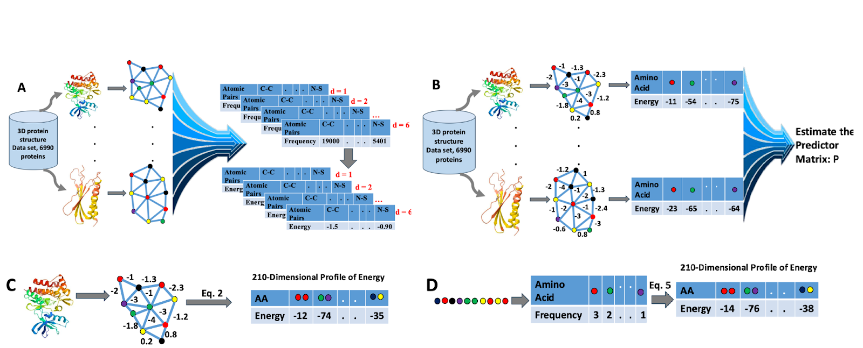

**Fig. 1|** A) Construction of the knowledge-based potential function. B) Estimation of the predictor matrix P. C) Construction of the structural profile of energy (SPE) based on protein structure. D) Construction of the compositional profile of energy (CPE) based on protein sequence.

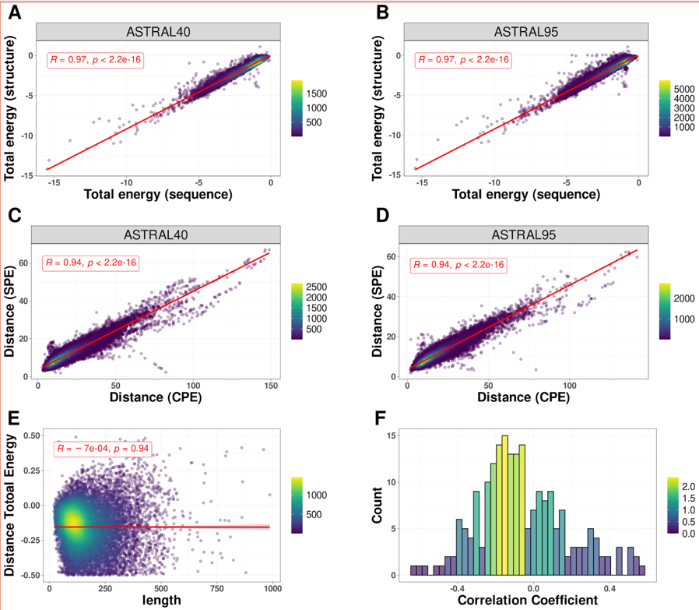

**Fig. 2 | Sequence-Structure relationship.** The correlation between total energy estimates derived from protein structure and sequence for protein domains within A) ASTRAL40 and B) ASTRAL95 data sets. The correlation between the distances of profile of energy estimated from sequence (CPE) and structure (SPE) for all pairs of domains in C) ASTRAL40 and D) ASTRAL95. E) The correlation between the difference in total energy (from sequence and structure) and protein length. F) Histogram showing the distribution of correlation coefficients between the difference in energy estimates (from sequence and structure) and protein length across all 210 pairwise interactions.

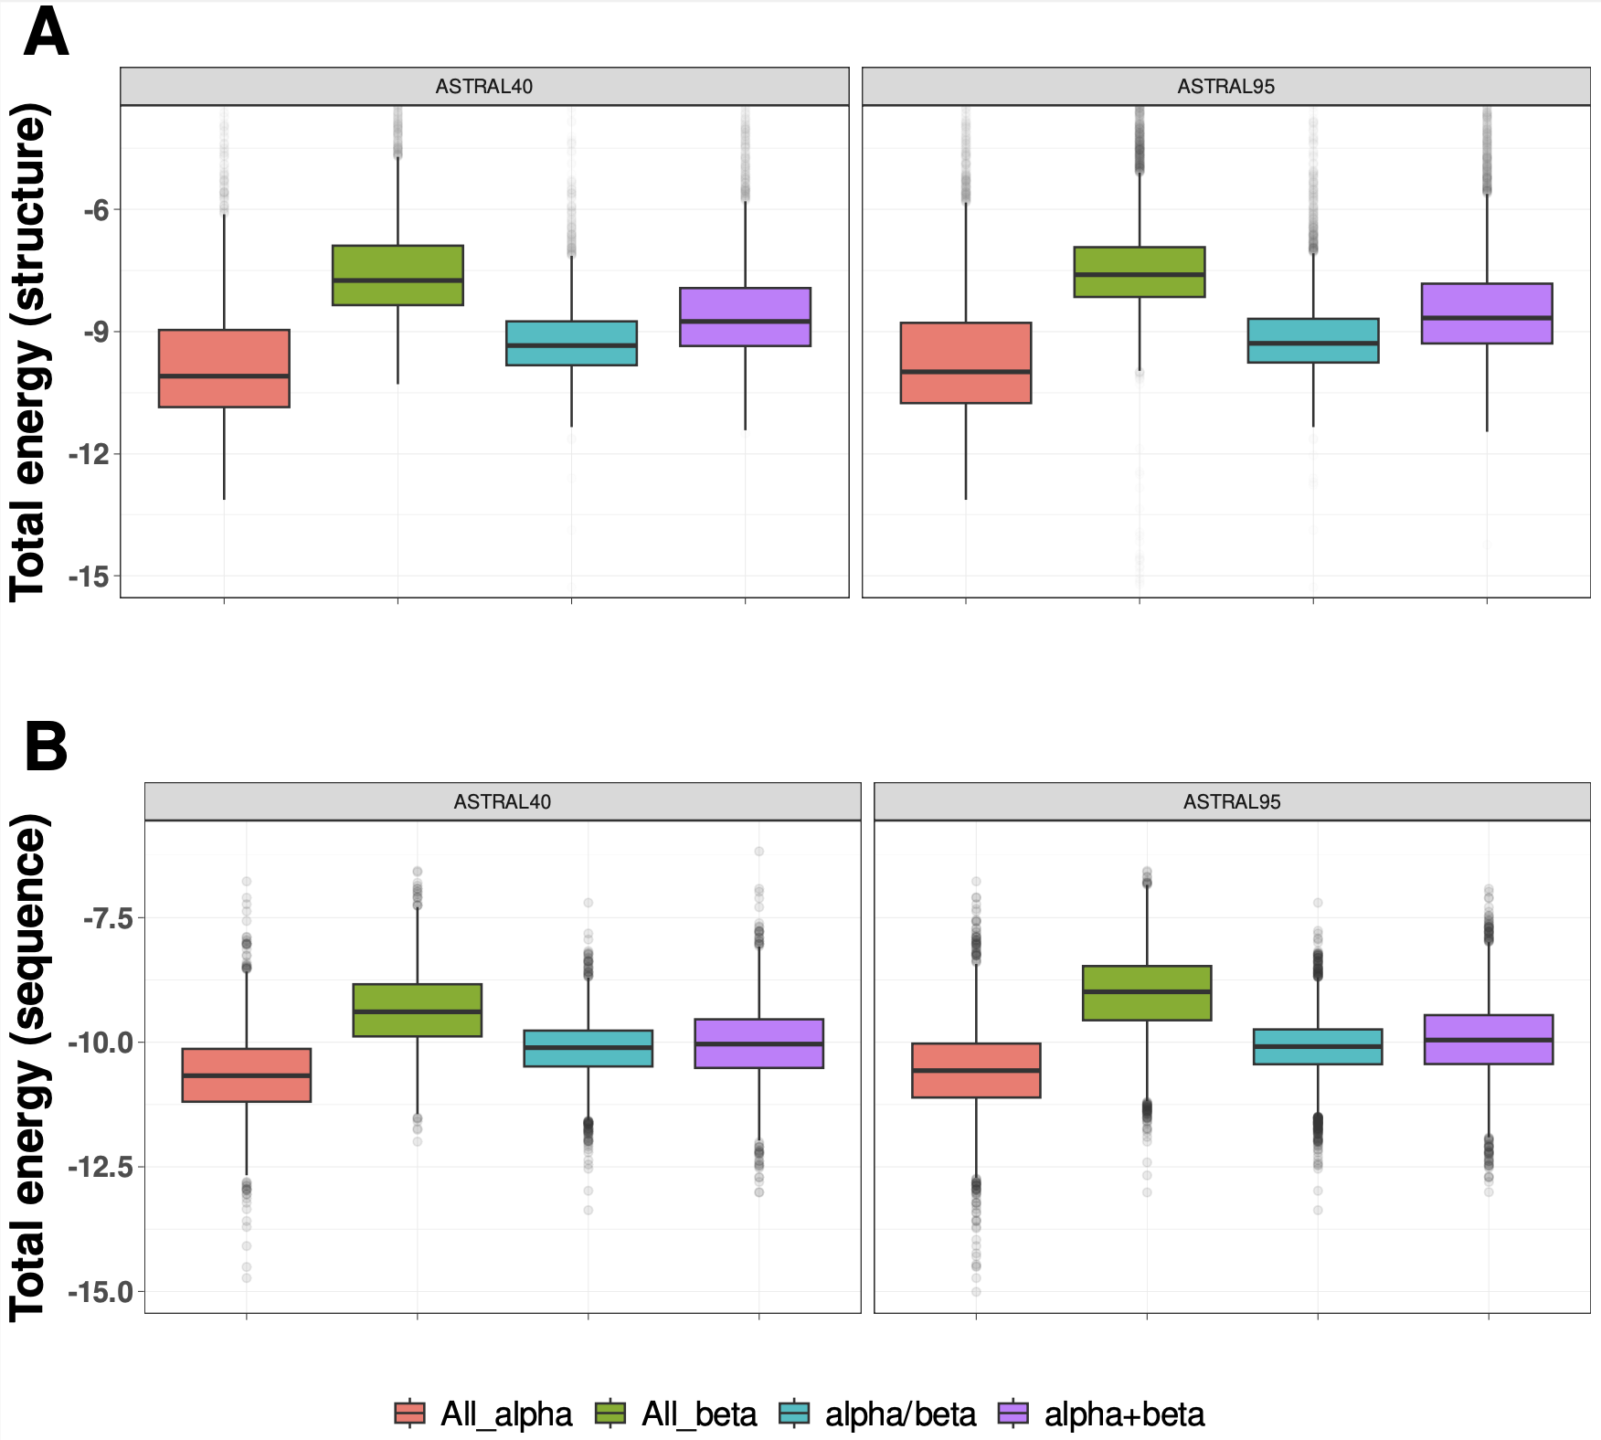

**Fig. 3 | Energy Distribution in Protein Domain Structural Classes.** The distribution of normalized total energy in protein domains from ASTRAL40 and ASTRAL95 datasets based on protein structure (A) and sequence (B) across various structural scope classes. In the ASTRAL40 dataset, there are 2644, 3059, 4463, and 3653 protein domains in the all-alpha, all-beta, alpha+beta, and alpha/beta classes, respectively. Similarly, in the ASTRAL95 dataset, there are 3443, 10164, 9344, and 7474 protein domains in the all-alpha, all-beta, alpha+beta, and alpha/beta classes, respectively.

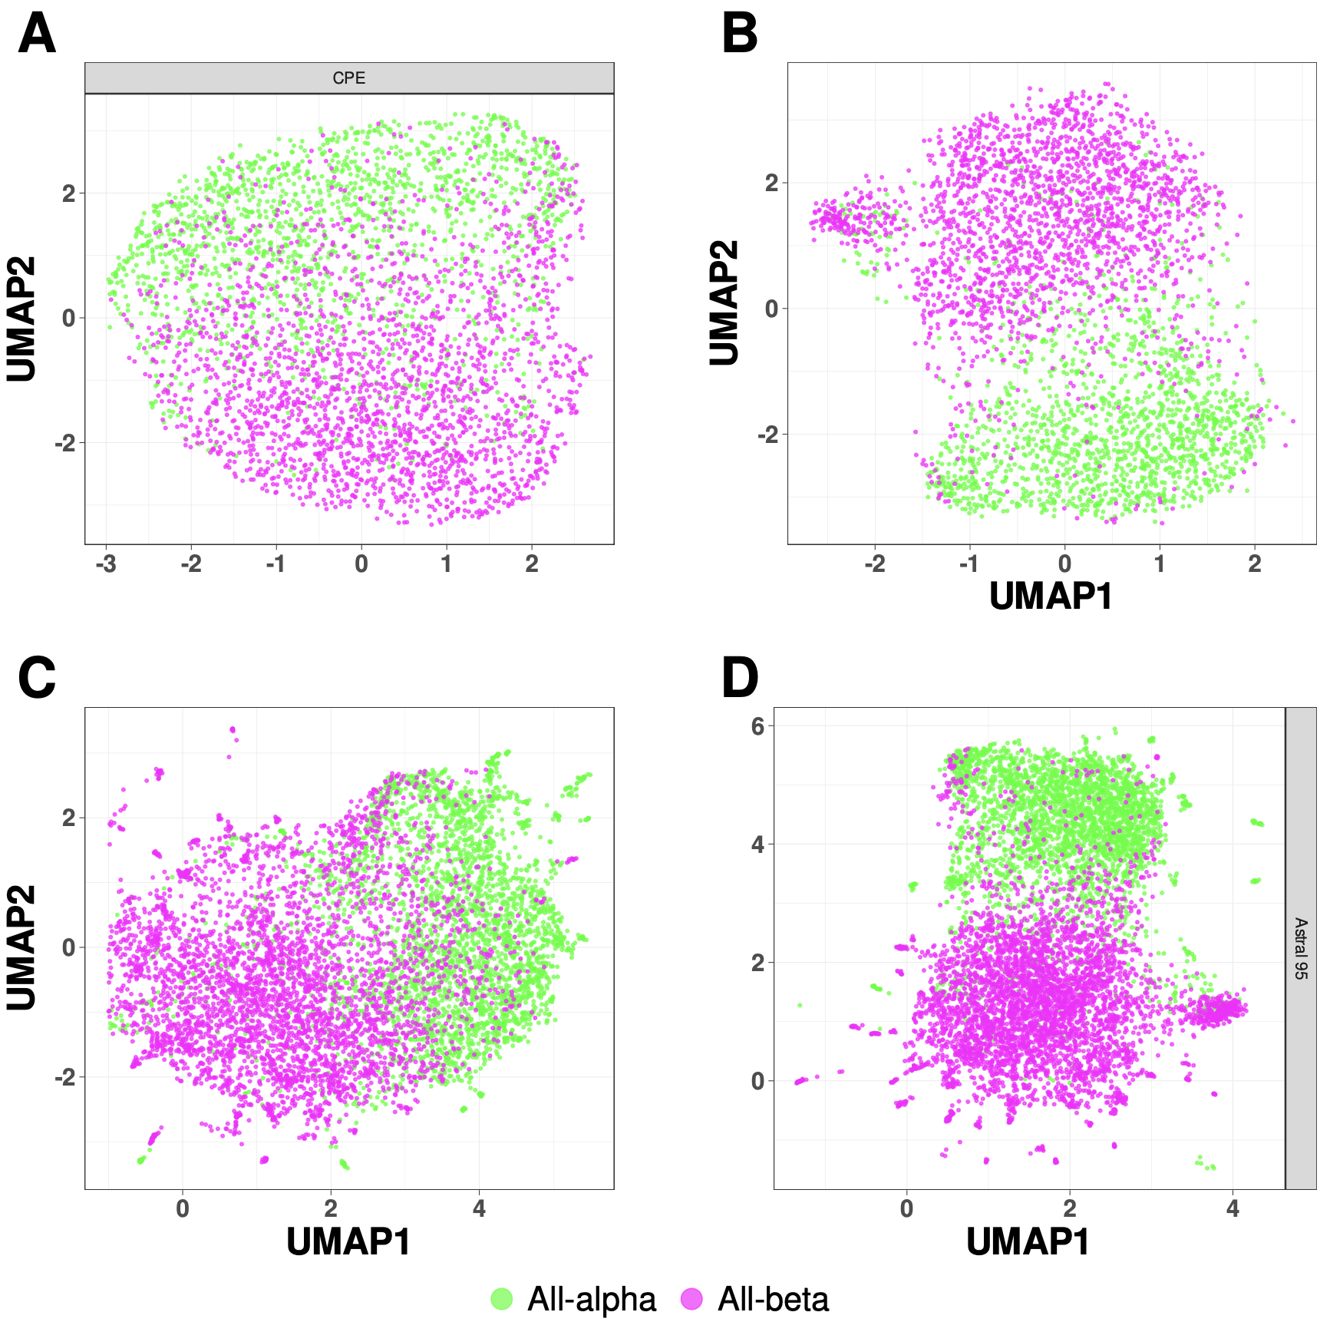

**Fig. 4 | UMAP Visualization of Energy Profiles in All-Alpha and All-Beta Domains from ASTRAL40 and ASTRAL95 Datasets.** UMAP projection of SPE and CPE shows the separation of the all-alpha (green point) and all-beta (pink point) proteins selected from the ASTRAL40 and ASTRAL95 datasets. A) CPE of ASTRAL40, B) SPE of ASTRAL40, C) CPE of ASTRAL95, and D) SPE of ASTRAL95. Dots represent two dimensional UMAP projection of SPE(CPE) for individual sequences. UMAP plots were generated by parameters n_neighbors = 20 and min_dist = 0.1.

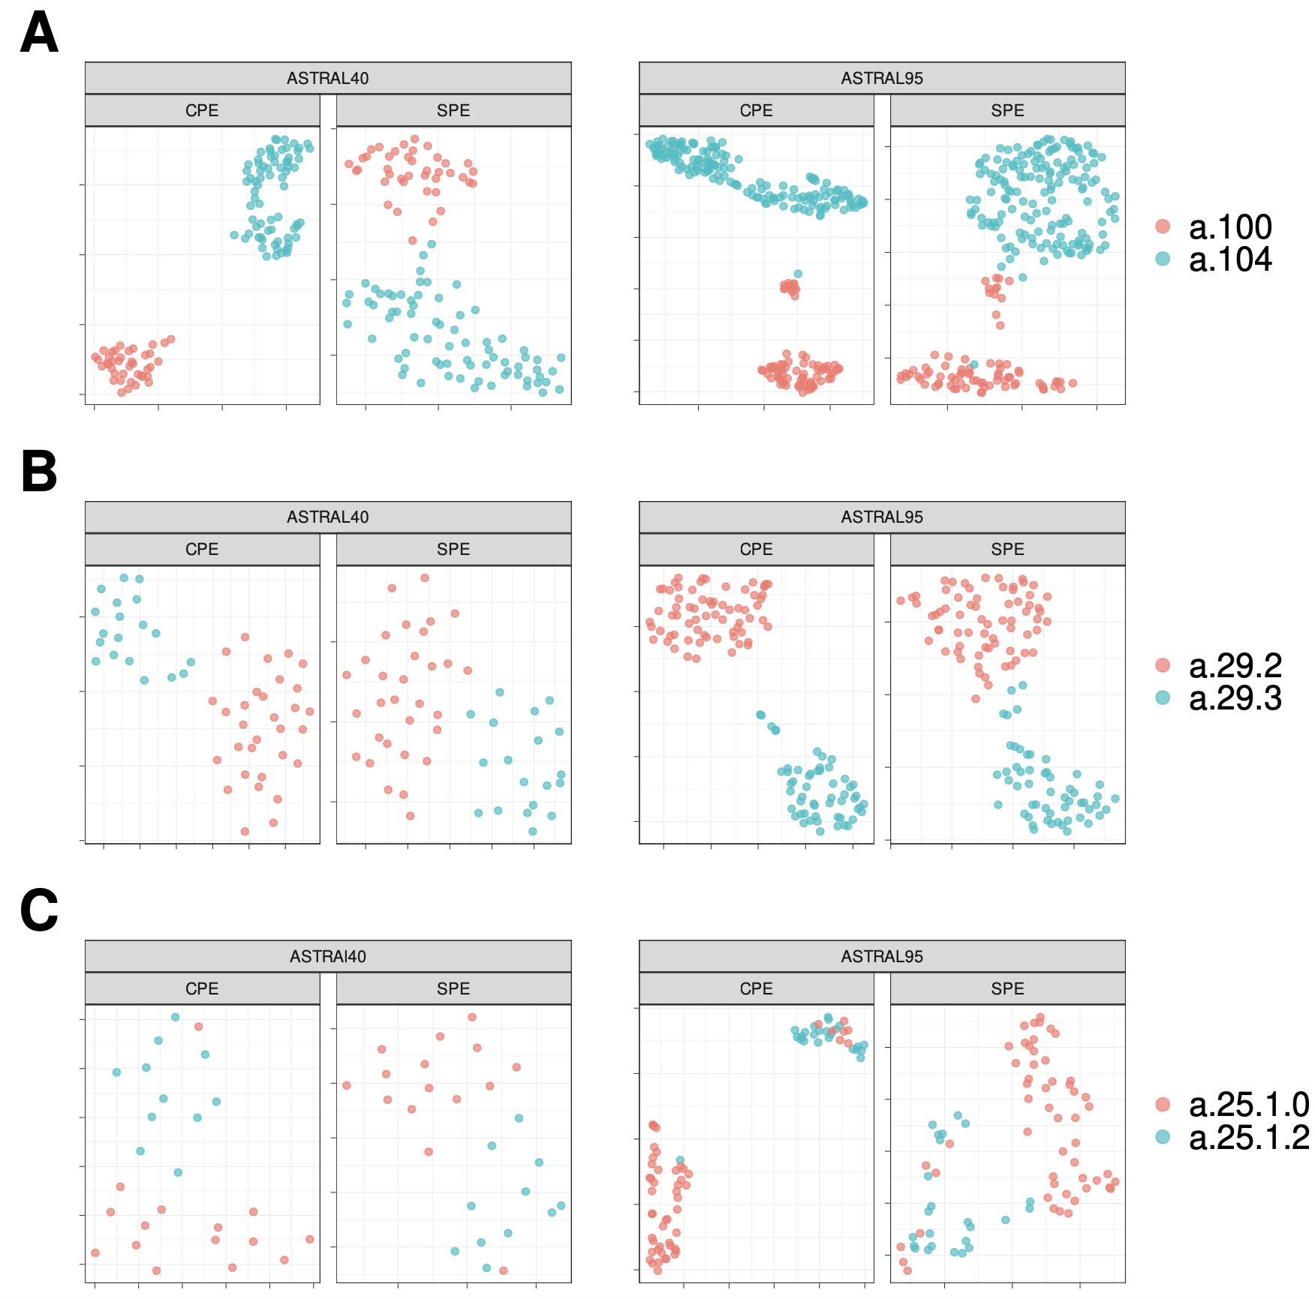

**Fig. 5 |** **UMAP Visualization of Energy Profiles.** The UMAP projection of Structural Energy Profiles (SPE) and Compositional Energy Profiles (CPE) of protein domains from ASTRAL40 and ASTRAL95 represents the structural information embedded in energy profiles across hierarchical levels of SCOP; each panel includes two figures, one generated by CPE (left panel) and the other by SPE (right panel), revealing that protein domains sharing the same A) fold, B) superfamily, and C) family exhibit comparable energy profile patterns. The folds a.100 and a.104, superfamilies a.29.2 and a.29.3, as well as families a.25.1.0 and a.25.1.2, are randomly selected for analysis, and the UMAP plots were generated using parameters n_neighbors = 20 and min_dist = 0.1.

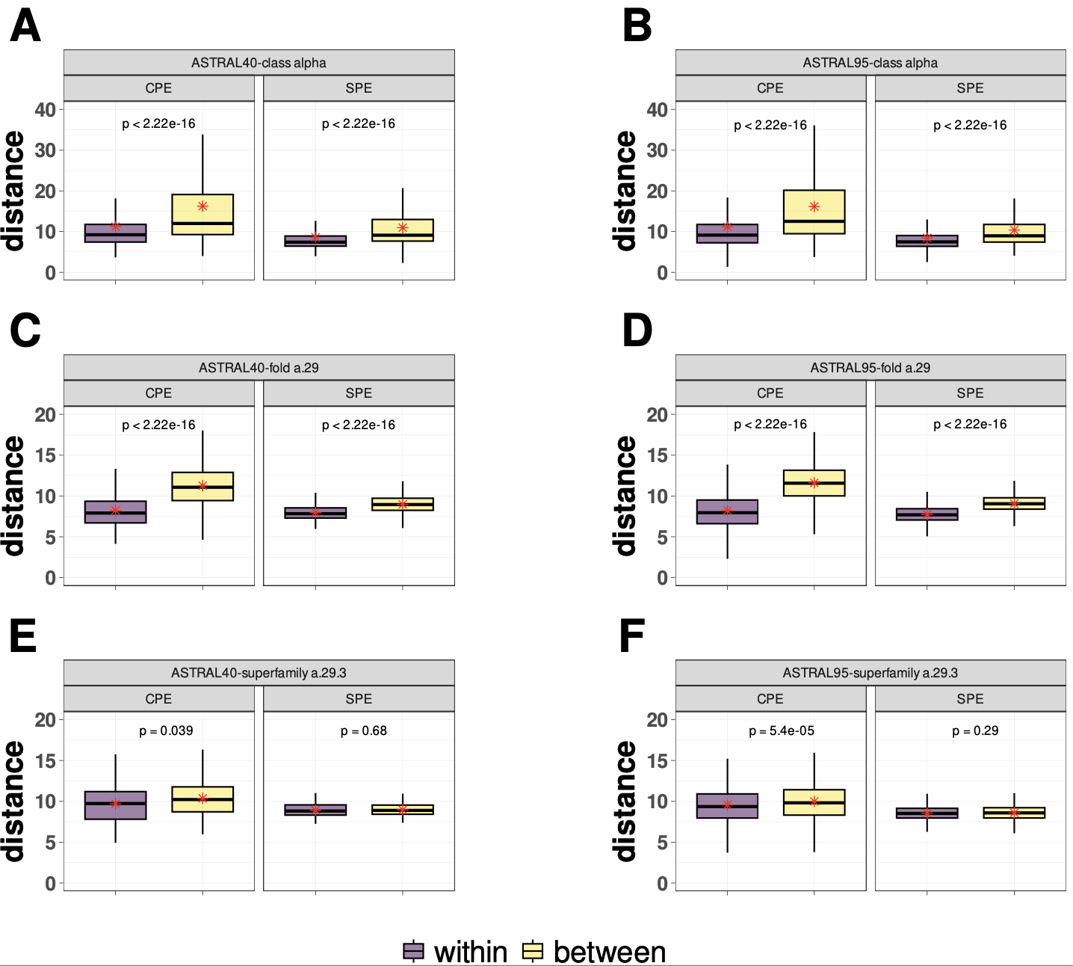

**Fig. 6 | Comparative Boxplots of Pairwise Distances among Energy Profiles in ASTRAL40 and ASTRAL95.** Comparative Boxplots of Pairwise Distances among Energy Profiles in ASTRAL40 and ASTRAL95, depicting A-B) intraclass distances within the all-alpha class (in purple) versus interclass distances (in yellow), C-D) intraclass distances within the a.29 fold (in purple) versus distances from protein domains in different folds within the all-alpha class (in yellow), and E-F) intraclass distances within the a.29.3 superfamily (in purple) versus distances from protein domains in different superfamilies within the fold a.29 (in yellow). Each panel presents two figures, one generated using Compositional Energy Profiles (CPE, left panel) and the other using Structural Energy Profiles (SPE, right panel).

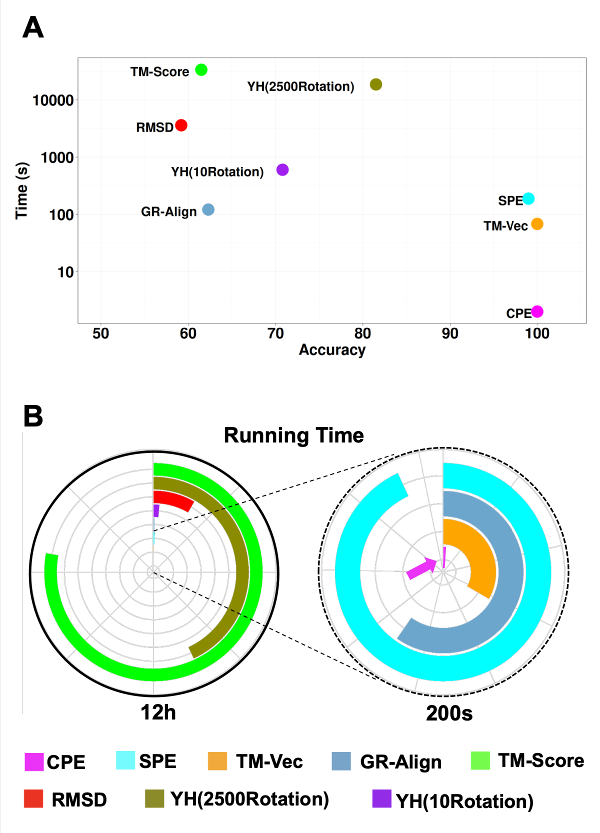

**Fig. 7 | Performance and Computational Efficiency of Protein Dissimilarity Measures**. A) Time versus accuracy for the 1-NN classifier using GR-Align, RMSD, TM-score, Yau-Hausdorff distance, TM-Vec, and the distance between energy profiles SPE and CPE as measures of protein dissimilarity. B) Running times of the evaluated methods, scaled to 12 hours, with an inset zooming in on the region indicated by the dashed circle. The entire circle represents 130 seconds. Each method is represented by different colors as indicated in the figure legend.



**Fig. 8 | The UMAP projection of α and β globins from the hemoglobin biological unit.** The figure shows the clustering of 21 mammalian hemoglobins, divided into α-globins and β-globins, using CPE, SPE, and TM-Vec representations.n_neighbors = 13, min_dist = 0.1

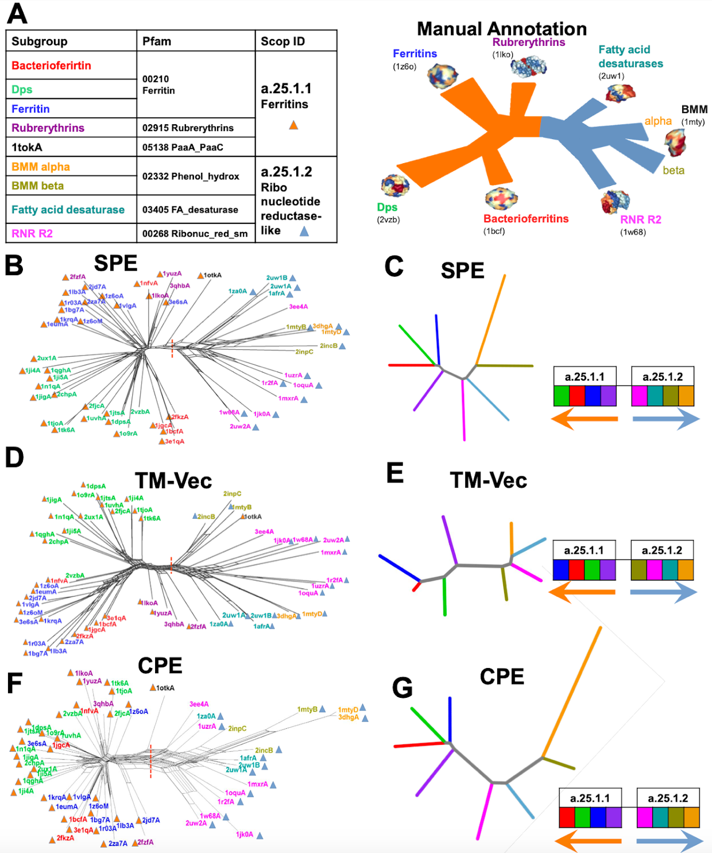

**Fig. 9 | Phylogenetic network reconstruction of the ferritin-like superfamily.** A) Schematic representation of the relationships among major ferritin-like protein families. B) Phylogenetic tree reconstructed using SPE. C) Neighbor-joining tree generated based on the average distances between subgroups using SPE. D) Phylogenetic tree reconstructed using TM-Vec. E) Neighbor-joining tree generated using average distances between subgroups with TM-Vec. F) Phylogenetic tree reconstructed using CPE. G) Neighbor-joining tree based on the average distances between subgroups using CPE. The red dotted line highlights the clear separation between two SCOP families: ferritins (SCOP ID a.25.1.1), which includes the Bacterioferritin, Ferritins, Dps, and Rubrerythrin subgroups, and the Ribonucleotide Reductase-like family (SCOP ID a.25.1.2), which includes the BMM-alpha, BMM-beta, Fatty_acid, and RNRR2 subgroups. The inferred arrangement of subfamilies using each method is shown to the right of C, E, and G.

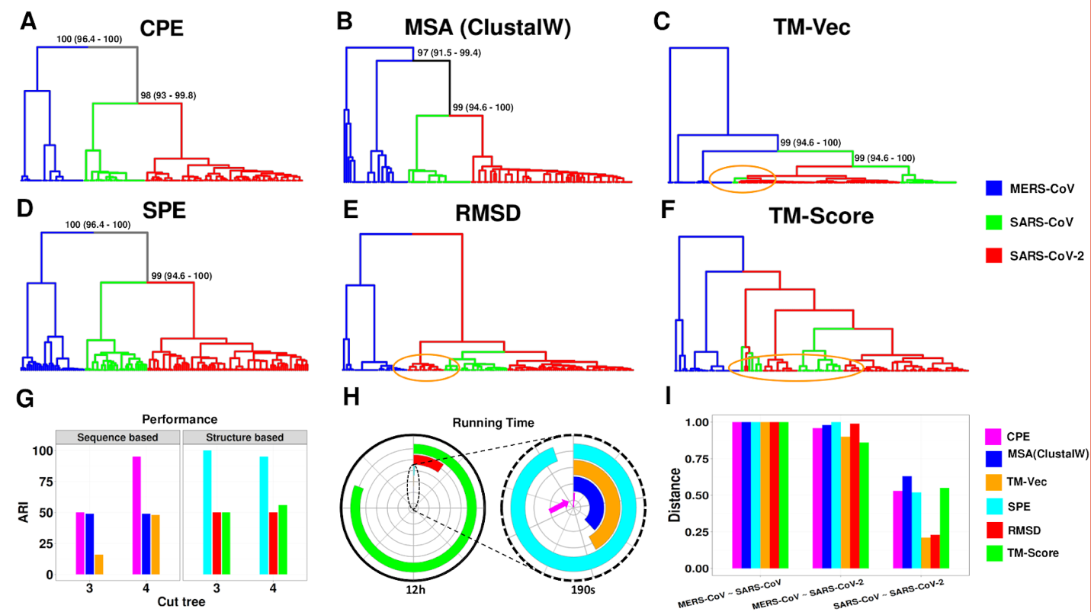

**Fig. 10 | Clustering analysis of spike glycoprotein structures from SARS-CoV, SARS-CoV-2, and MERS-CoV.** The dendrograms depict the clustering of spike glycoprotein structures from the three viruses: SARS-CoV, SARS-CoV-2, and MERS-CoV. The clustering is based on pairwise distances calculated from different methods: **A)** CPE, **B)** protein sequence, **C)** TM-Vec, **D)** SPE, **E)** RMSD, and **F)** TM-Score. The leaves of each tree are color-coded to indicate the originating virus for each spike glycoprotein structure. **G)** Displays the ARI values for each method, **H)** shows the running time associated with each method, and **I)** presents the average distance between the three virus groups as calculated by each method.

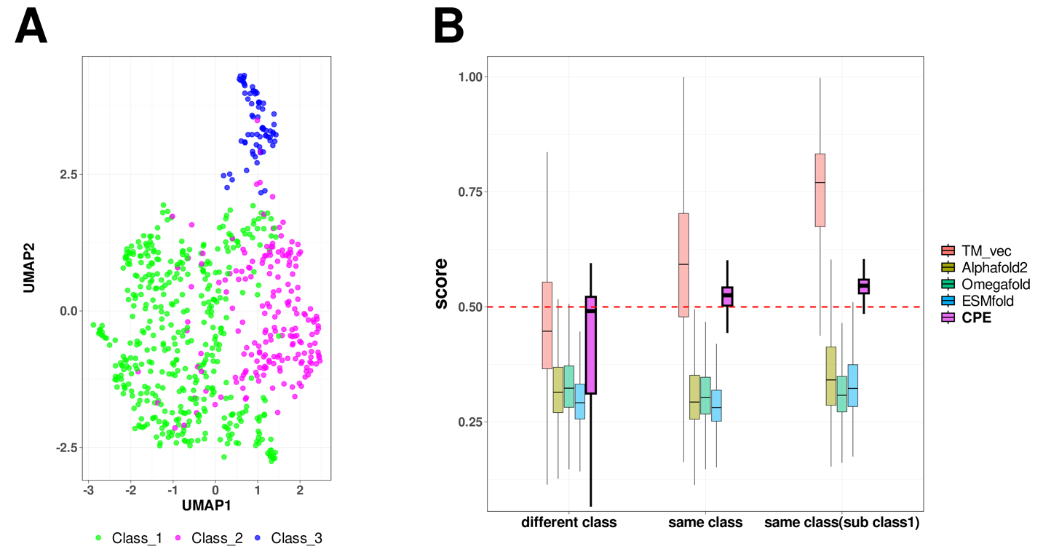

**Fig. 11 | UMAP Visualization and Comparison of Embeddings for Bacteriocins.** Visualization of profile of energies embeddings using UMAP for 689 peptides across three classes of bacteriocins. A) The UMAP projection of Compositional Energy Profiles (CPE) on bacteriocins at different classes. B) Comparison of CPE distances (CPE_dis) with the TM-scores produced by running TM-align on structures predicted by AlphaFold2, OmegaFold and ESMFold, and TM-Vec for 238,000 pairs of bacteriocins. CPE_dis is normalized by min-max normalization

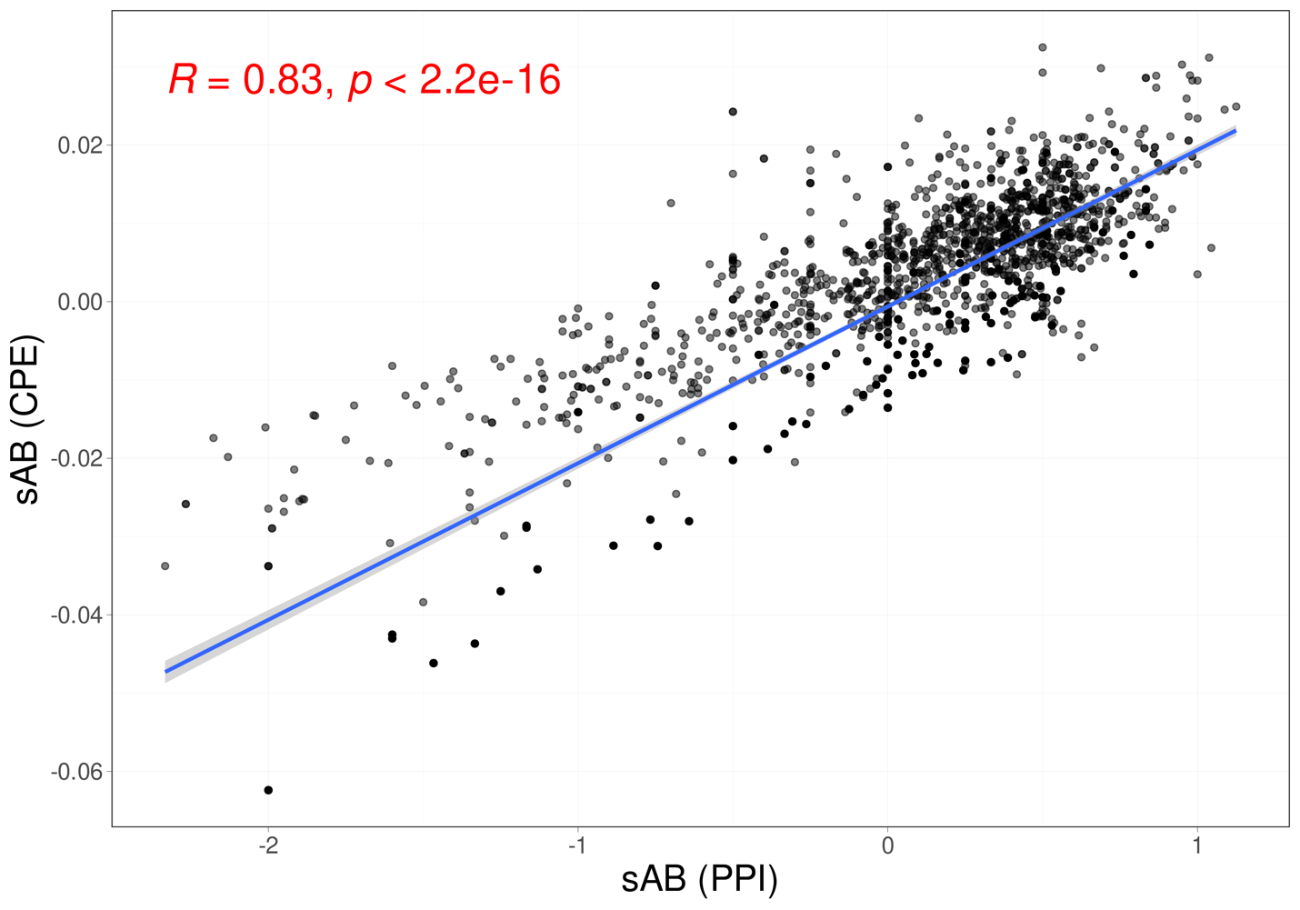

**Fig. 12 | Correlation between Protein-Protein Interaction Network Distances and Profile of Energies Distances.** The correlation between separation distances estimated by protein-protein interaction network (X-axis) and the distance between profiles of energies (Y-axis).



**Fig. 13| Papain-like Protease (PLPro) domains across Betacoronavirus subgenera.** The UMAP projection shows clustering of PLPro domains from Sarbecovirus (n = 31), Nobecovirus (n = 11), Merbecovirus (n = 35), and Embecovirus (n = 45) using TMVec, CPE and SPE representations. n_neighbors = 13, min_dist = 0.5.



**Fig. 14 | Scalability of CPE and TM-Vec.** Processing time per amino acid for subsets from the Astral95 dataset, ranging in size from 1,000 to 30,000 proteins (at intervals of 5,000).

**Table 1 |** The accuracy and computation time for 1-NN classifier based on GR-Align, RMSD, TM-score, Yau-Hausdorff distance, TM-Vec, and the distance between profiles of energy SPE and CPE as a measure of protein dissimilarity.

|  |  |  |
| --- | --- | --- |
| **Method** | **Accuracy** | **Time** |
| **GR-Align** | 62.3% | 2 min |
| **RMSD** | 59.2% | 1 h |
| **TM-Score** | 61.5% | 9 h 20 min |
| **YH (10 Rotation)** | 70.8% | 10 min |
| **YH (2500 Rotation)** | 81.5% | 4h 10 min |
| **TM-Vec** | 100% | 67 sec |
| **CPE** | 100% | 1 sec |
| **SPE** | 99% | 187 sec |

**Table 2 |** Total accuracy and F1 measure for each of the five superfamilies by 1-NN and the results of 10-Fold cross validation with random forest (RF) based on CPE, SPE, and TM-Vec.

|  |  |  |  |  |  |  |  |
| --- | --- | --- | --- | --- | --- | --- | --- |
| **Method** | **Time** | **Accuracy** | **F1 Measure** | | | | |
| **wigend_helix** | **PH.domain-like** | **NTF-like** | **Ubiquitin-like** | **Immunoglobulins** |
| **CPE (1NN)** | 103 Sec | 0.98 | 0.98 | 0.96 | 0.99 | 0.99 | 0.99 |
| **CPE (RF)** | 103 Sec | 0.99 | 0.97 | 0.97 | 0.99 | 0.99 | 0.99 |
| **SPE (1NN)** |  |  |  |  |  |  |  |
| **SPE (RF)** |  |  |  |  |  |  |  |
| **TM_Vec** **(1NN)** | 955 Sec | 0.99 | 0.99 | 1 | 1 | 0.99 | 0.99 |

**Table 3 |** Spearman Correlation Between the Manual Network and Predicted Branching Orders by SPE, TM-Vec, and CPE

|  |  |  |
| --- | --- | --- |
| **Method** | **a.25.1.1** | **a.25.1.2** |
| **CPE** | 0.8 | 0.6 |
| **SPE** | 1 | 0.6 |
| **TM_Vec** | 0.2 | -0.4 |

**Table 4 |** Comparison of clustering results using Adjusted Rand Index (ARI)

|  |  |  |  |
| --- | --- | --- | --- |
| **Method** | **Type** | **Cut Tree** | **ARI** |
| **CPE** | Sequence-Based | 4 | 0.95 |
| **MSA** | Sequence-Based | 3 | 0.49 |
| **TM-Vec** | Sequence-Based | 5 | 0.87 |
| **SPE** | Structure-Based | 3 | 1.00 |
| **RMSD** | Structure-Based | 6 | 0.73 |
| **TM-Score** | Structure-Based | 4 | 0.56 |

**Table 5 |** Large Scale: Analysis of the SARS-CoV-2 Proteome across 28 families, encompassing 4,405 proteins. The overall accuracy, F1 score, and computation time for detecting families using the 1-NN classifier.

|  |  |  |  |
| --- | --- | --- | --- |
| **Method** | **Time (Sec)** | **Accuracy** | **F1 Measure** |
| **CPE** | 49 | 0.9968 | 0.9946 |
| **SPE** | 2715 | 0.9973 | 0.9903 |
| **TM_Vec** | 685 | 0.9966 | 0.9925 |